Microsoft Word 2007 Quick Reference Guide
Create a New Document  - To open a new, blank document, click the Microsoft Office Button at the top left of the window  - Click New. In the New Document dialog box, double-click Blank document.  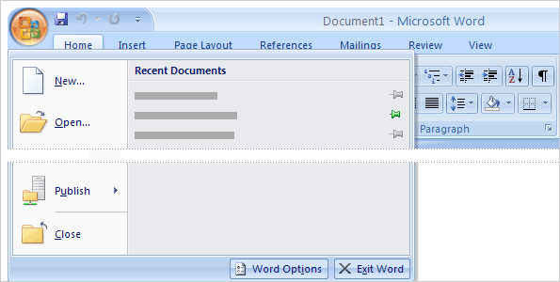 | Printing  - To print a document, click the Microsoft Office Button at the top left of the window  - Click Print. Click the one of the following options: Print, Quick Print, or Print Preview.  - Once clicking Print, choose the options that you want, such as the number of pages or which pages you want to print  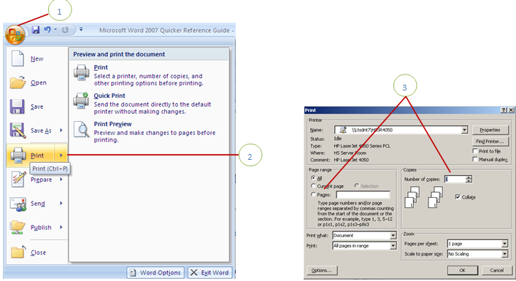
Saving  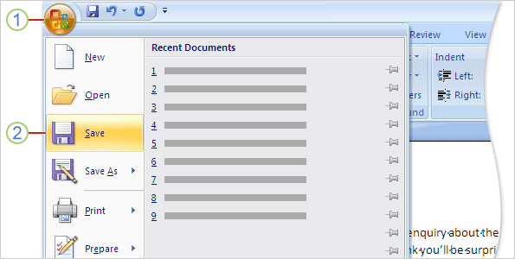  To save your new document, click the Microsoft Office Button.  Then click Save. A dialog box opens. Use this box to tell Word where you want to store the document on your computer, and what you want to call it. | Formatting  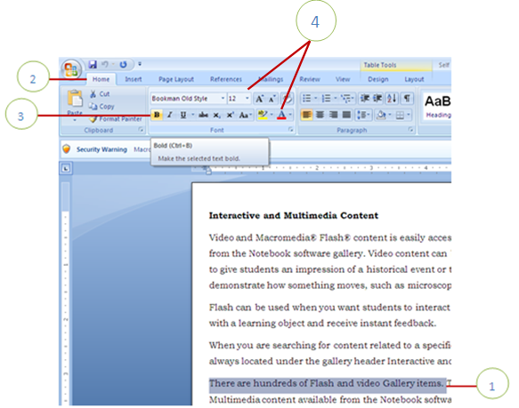  - Select the text you want to call attention to.  - Click on the Ribbon, then on the Home tab.  - In the Font group, choose how to format the text. For example, click Bold  - You can change the font color by selecting the text, then on the Home tab, in the Font group, point to Font color or changing the size of the font, by clicking on Font size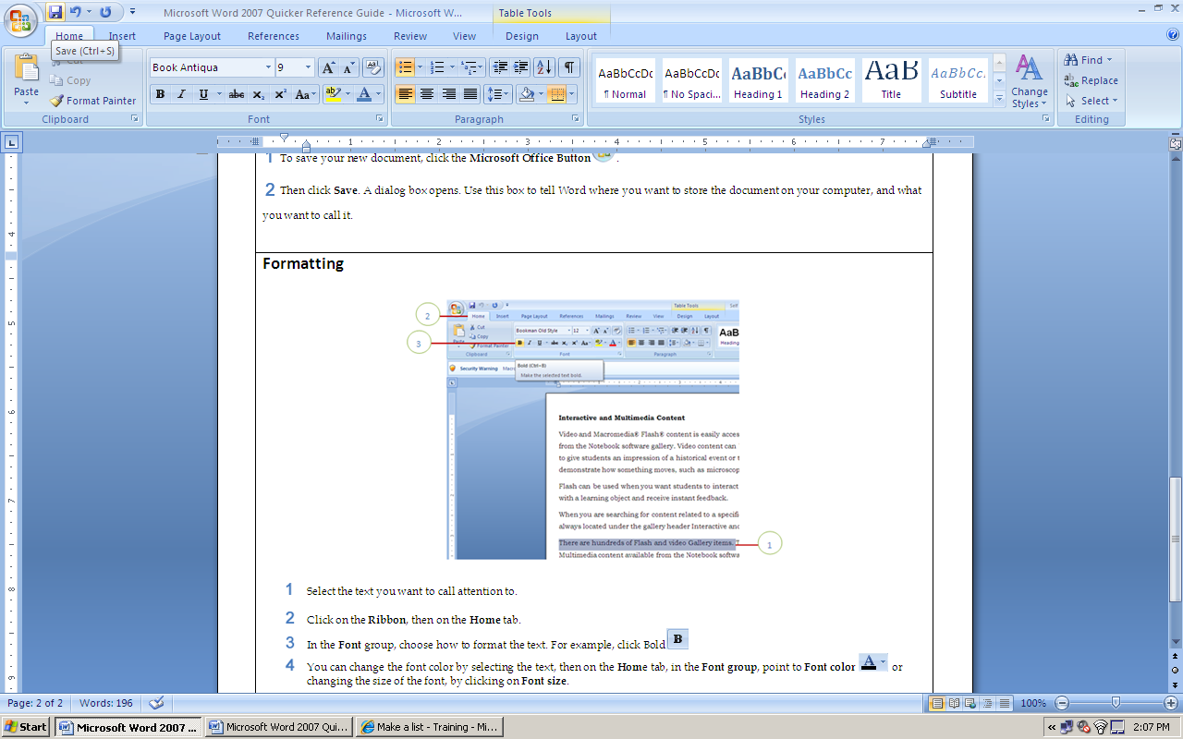.
Spelling and Grammar  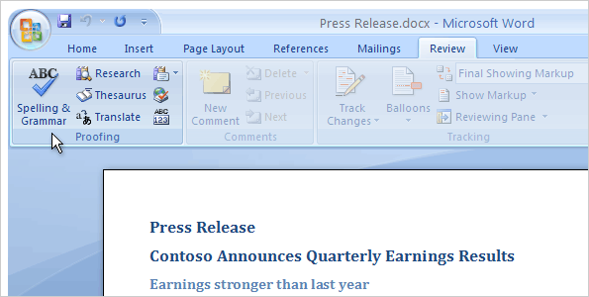  - To check spelling and grammar, click on the Review tab, because this is part of reviewing your work.  - Look toward the far left, in the Proofing group and click on Spelling & Grammar. | Sharing documents between versions by saving with an older format  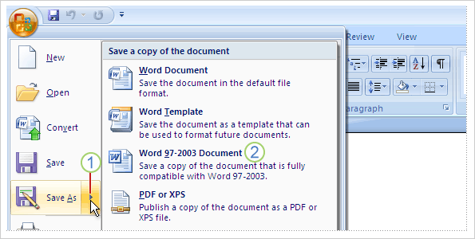  If you're concerned that no one will be able to read your Microsoft Word 2007 document when sharing, then you will want to save the document with an older file format before sending it.  Click the Microsoft Office Button, and on the menu, point to the arrow at the end of the Save as command.  Click Word 97-2003 format on the list of options.  You may get a warning that saving in the older file format will cause certain features to be lost or modified.
ClipArt and WordArt  - On the Ribbon, click the Insert tab, and click ClipArt or WordArt.  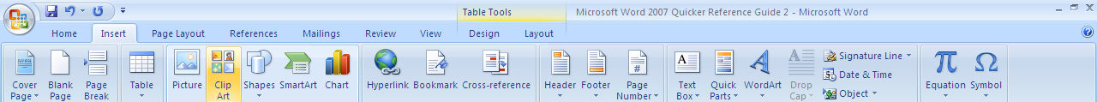  - In the dialog box that appears, type the text that you want in the WordArt in place of "Your Text Here." You can change the font type or size here, and apply bold or italic formatting.  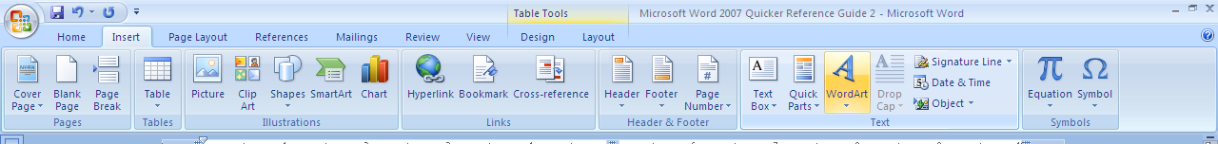  - When you're ready, click OK. | Bullets, Numbers, and Lists  You can start a list in Microsoft® Office Word 2007 by using the Bullets button or Numbering button in the Paragraph group on the Home tab. Or you can automatically create a list as you type.  

